Pickleball Study Guide

A pickleball court and a badminton court are similar in size.

Serving in picklball is done with a underhand swing.

At the start of a game the serve is made to the right service box of your opponent

The two bounce rule makes it so both players have to let the ball bounce once on their side before any sort of volley can take place.

Spiking a pickleball is allowed outside of the no volley zone.

The no volley zone is a distance of 7ft from both sides of the net where a player cannot strike the ball out of the air.

Pickleball games are played to a score of 11 with the winner having to be ahead by two points.

Server must alternate sides between serves.

A pickleball net is 36 inches high.

A team or player can only score when they serve, this type of scoring is called sideout scoring.

Doubles completion is when there are two players on each team.

Both feet need to be behind the line when serving.

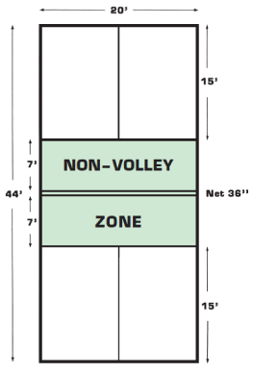

End line is 20 ft wide, the side line is 44 ft long. The court is divided into right and left service boxes as you are looking at the net.